Revising the CollateGene Patient Population Forecast
  - A published prevalence range with infection reassessment and recurrence in remission
David G. Armstrong, DPM, MD, PhD
For Charles M. Zelen and the AnGes team for discussion with IQVIA
Population range revision 8 September 2026
Infections are transient. CLTI is permanent and progressive.
Treating an infection does not erase chronic arterial disease. Healing a wound begins remission, during which recurrence remains common. The forecast must follow the person through active disease, infection treatment, healing, remission and return to active disease. A snapshot of new diagnoses cannot, on its own, describe that continuing clinical population. [2–6,20]
Use a 1–2 million US CLTI disease-pool range. Callegari et al cite approximately 1 million US patients; Barnes et al summarize approximately 2 million adults over 40. Carry both published benchmarks through the model, with 1.5 million as an illustrative midpoint. These are existing disease populations, not annual new diagnoses or immediate gene-therapy candidates. [22,23]
Clinical eligibility must be measured from the patient’s actual condition and treatment criteria. CLIPPER’s 9.4%, the derived 14.7% average and IQVIA’s unvalidated 19% must not be used as automatic treatment exclusions. [1,9,10,17]
Assessment pathway | Callegari [23] | Midpoint* | Barnes [22]
US CLTI disease pool | 1,000,000 | 1,500,000 | 2,000,000
Entering assessment with active disease | 1,000,000 × A | 1,500,000 × A | 2,000,000 × A
After provisional infection step | 900,000 × A | 1,350,000 × A | 1,800,000 × A
Meeting all treatment criteria | Measure | Measure | Measure

*The midpoint is an arithmetic scenario, not a third published estimate. A is the share entering assessment with active disease in the stated period; it must be measured. The 10% non-return after infection is a planning assumption. The 1–2 million span is a range of published benchmarks, not a confidence interval or harmonized national estimate.
Recognize the chronic disease pool, preserve a route back after infection, and assess wound, perfusion and treatment criteria. Prescribing and access then determine how many eligible people receive treatment.

Why column one should begin with the chronic disease pool
The model should answer the commercial question the disease actually presents: how many living people have active or recurrent CLTI that can become clinically addressable during the planning period? An estimate of first diagnoses is one inflow to that pool. Existing patients with persistent disease and patients returning from remission are additional sources of clinical evaluation.
Source | Published estimate | Use in this review
Callegari et al 2024 [23] | Approximately 1 million US patients with CLTI; up to 11% of PAD patients. | 1.0 million benchmark. Background synthesis in a prognostic PVI study, not a new national prevalence survey.
Barnes et al 2020 [22] | CLTI prevalence 1.28% in US adults over 40, approximately 2 million people. | 2.0 million benchmark. Review synthesis citing Duff et al 2019; preserve its age denominator and underlying source period.
Deng et al 2025 [15] | GBD 2021: 16.41 million with PAD in high-income North America (95% UI 14.68–18.34 million). | PAD context, not a third US CLTI estimate. The regional total is not the US total and cannot be multiplied by 11% to establish US CLTI prevalence.

The two CLTI papers support a 1–2 million span of published benchmarks. We carry 1.0 and 2.0 million as the endpoints and 1.5 million as an illustrative midpoint, without selecting the lower endpoint as the sole base. This span is not a confidence interval, a pooled estimate or a bound on all possible estimates. Differences in year, age, coding and clinical definition require reconciliation. [22,23]
Nehler et al reported annualized CLI prevalence of 1.33% and incidence of 0.35% in an insured study population; the AHA statement summarizes severe PAD burden at approximately 1.3% of US adults. These support the stock-versus-inflow distinction but do not create independent national counts. Harmonize all benchmarks to IQVIA’s age-50-and-older target before estimating annual assessment or treatment. [12,21]

Correct the column label and its time basis
Replace the stand-alone “Incident CLTI Population” presentation with “US CLTI disease pool and patients entering evaluation during the model period.” Reconcile three nonoverlapping components: active untreated patients carried into the year; patients receiving a first diagnosis during the year; and previously diagnosed patients returning with a new eligible episode. The model must also retain a separate remission population that can feed future years.
A 1–2 million-person disease stock and approximately 291,000 annual first diagnoses can coexist. They are not competing incidence estimates. A larger stock may support more patients reaching evaluation, but the number treated in a particular year depends on clinical activation, survival, referral, treatment capacity and access. The workbook should calculate that bridge, rather than making the existing population disappear after the original launch allocation.

From the disease pool to clinical assessment
The figure carries both published US CLTI benchmarks and the illustrative midpoint through the same assessment pathway. The 1–2 million disease pool becomes 1–2 million × A entering assessment, then 0.9–1.8 million × A after the provisional infection step. Individual treatment eligibility remains to be measured. [22,23; calculation]
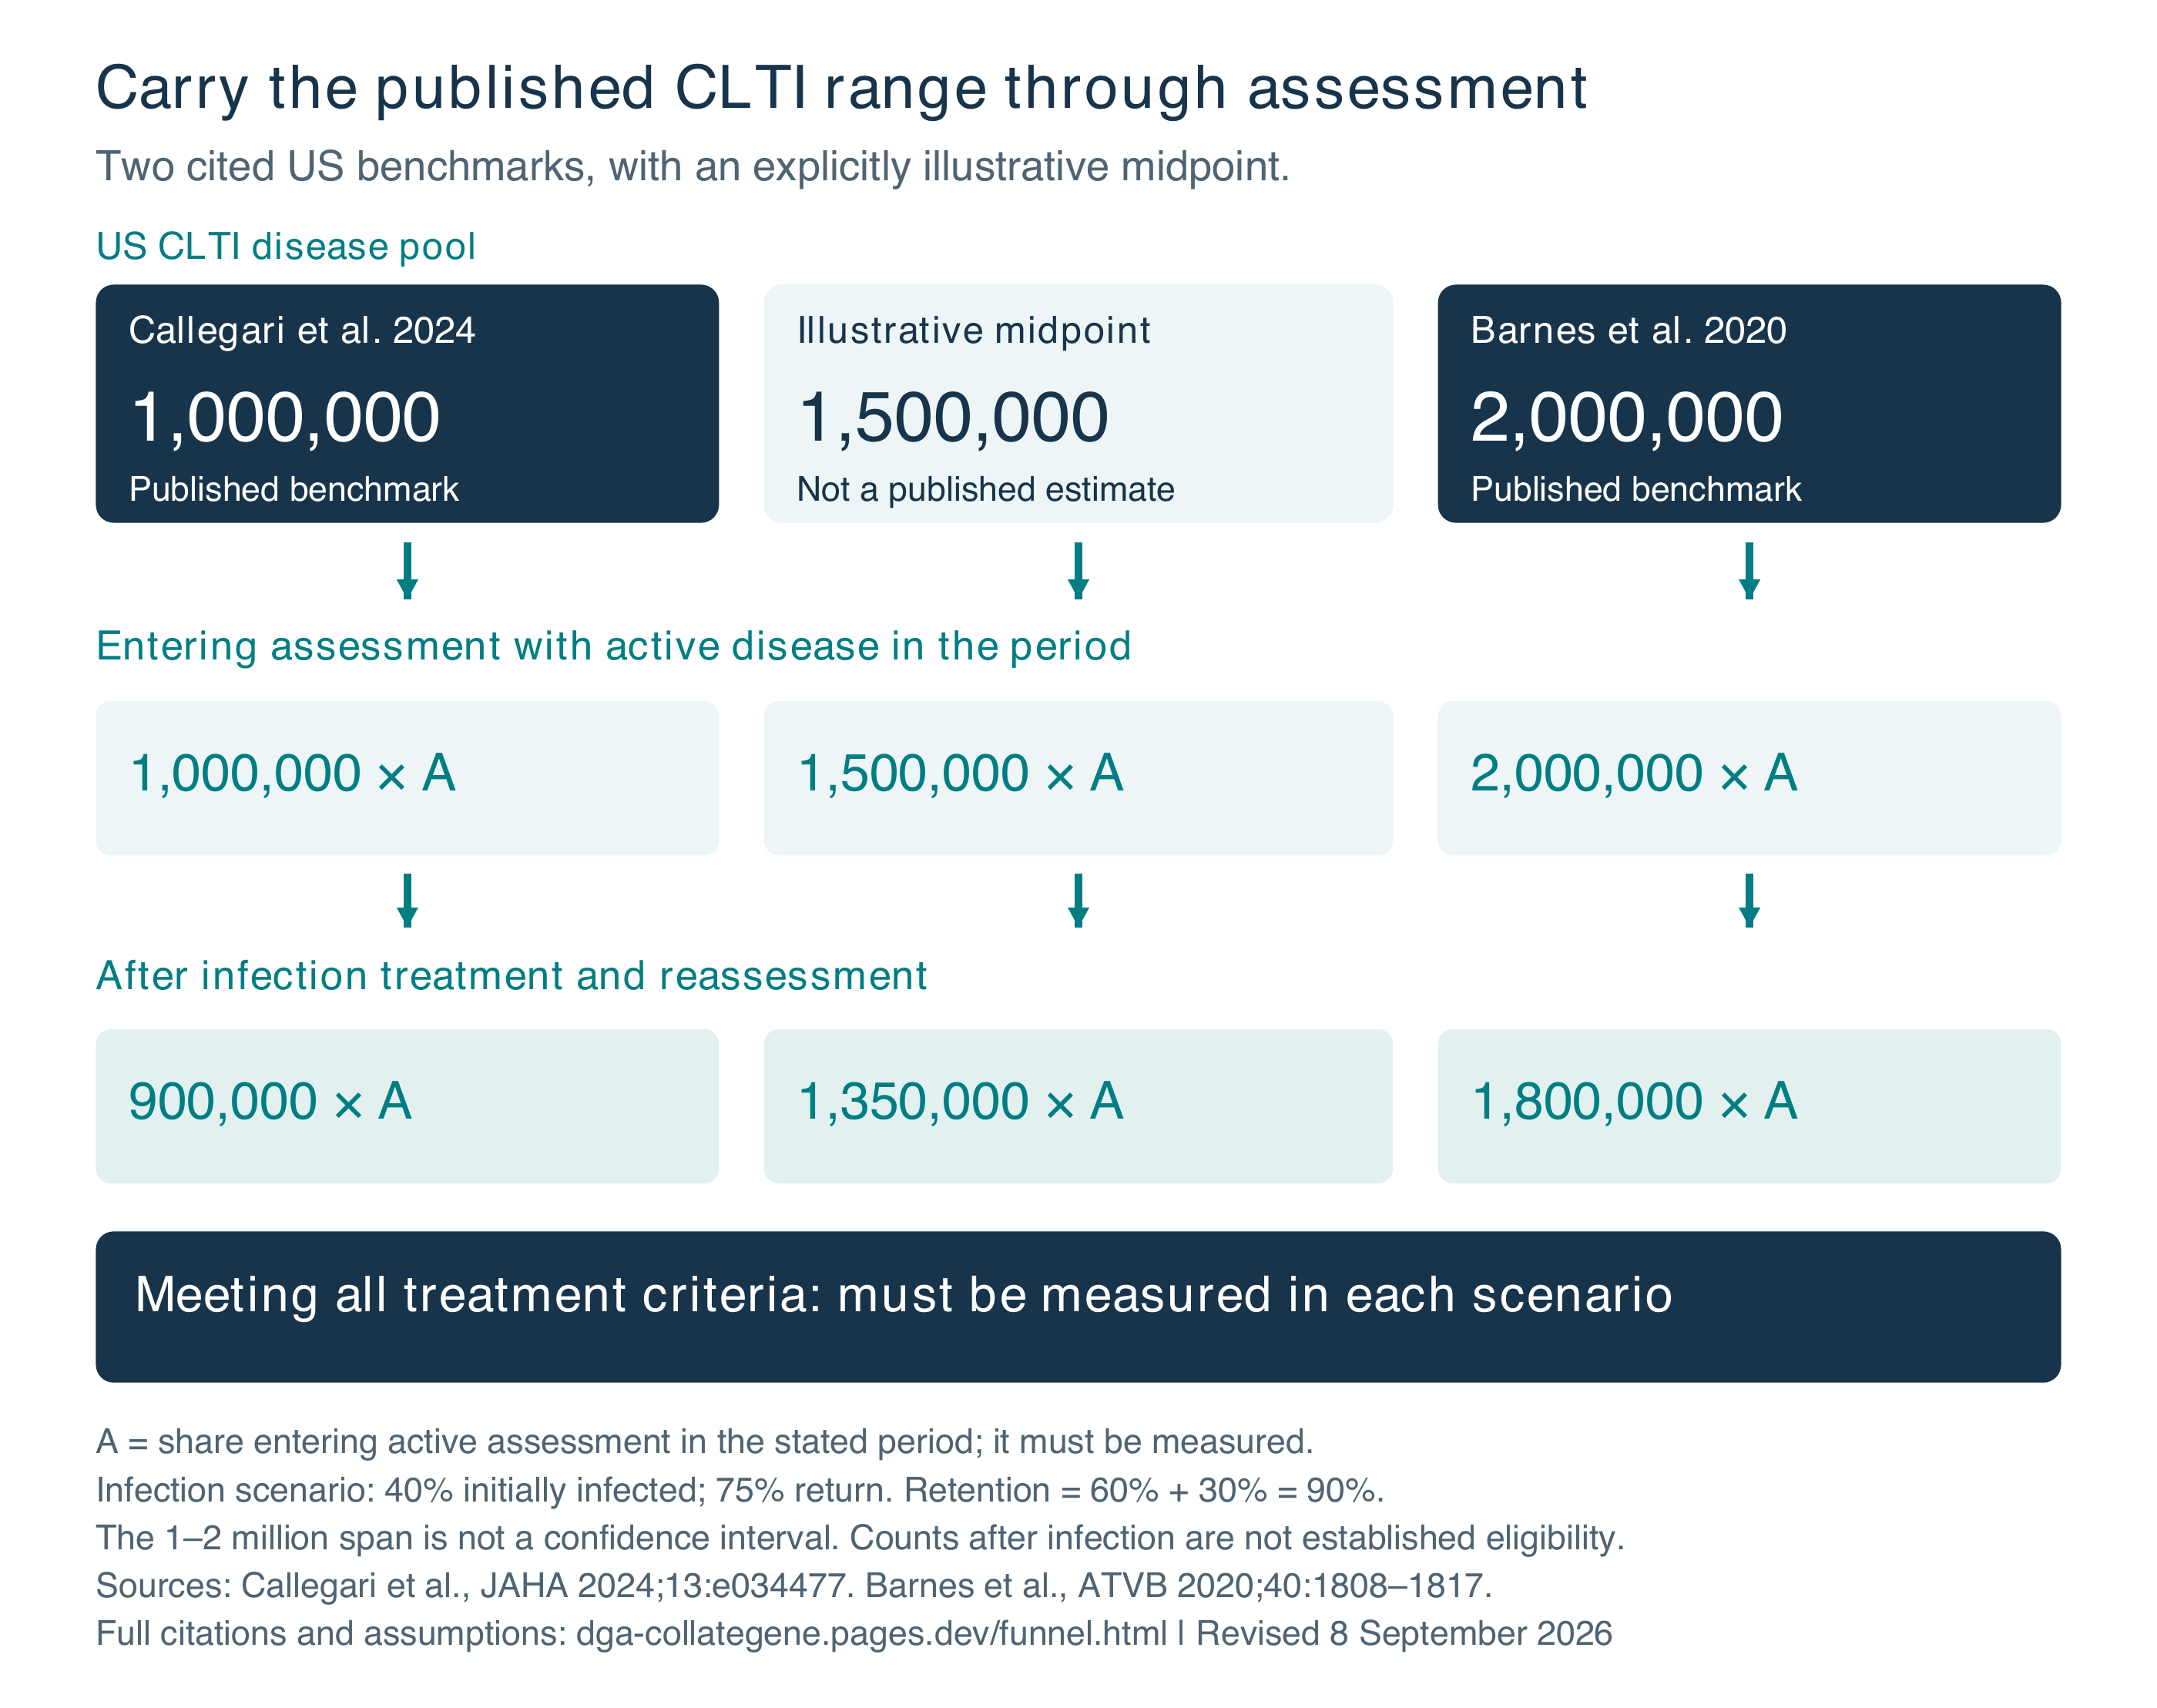
Figure 1. Callegari and Barnes provide the 1.0 and 2.0 million CLTI benchmarks; 1.5 million is an illustrative midpoint. A is the share entering assessment with active disease in the period. The infection step is conditional arithmetic, and the final eligible number must be measured.
A longitudinal model can produce a substantial evaluable population without treating every prevalent patient as a new annual diagnosis. It should make that bridge explicit and follow those still awaiting assessment into the next period.

Infection treatment preserves a route back to eligibility
The central question is not how many patients have an infection at their first encounter. It is how many remain unsuitable after appropriate treatment, when they can be reassessed, and whether they still have an unhealed, label-eligible ischemic wound. IQVIA’s July response already acknowledges that patients may regain eligibility after infection resolution. The forecast should implement that acknowledgement. [1]
Evidence | Observed finding | What the model can infer
ADA clinical monograph  Boulton et al 2018 [4] | Reports infection resolution above 90% for mild or moderate soft-tissue infection, and above 75% for osteomyelitis and severe infections with appropriate care. | Direct support for substantial treatability. This is a clinical synthesis, not a measured return-to-CollateGene eligibility rate. Severe PAD and renal failure reduce success.
Randomized pilot trial  Pham et al 2022 [5] | 66 soft-tissue DFI episodes after debridement; 42 had PAD. Remission occurred in 27/35 and 22/31, or 49/66 overall (74.2%). | Approximately three-quarters achieved remission in a cohort with substantial PAD. Osteomyelitis was excluded; not a dedicated CLTI population.
Ischemic DFI cohort  Altmann et al 2023 [6] | Among 608 revascularized episodes, 426 (70.1%) had clinical remission; 182 (29.9%) failed clinically, including 98 major amputations (16.1%). | Ischemic infection is often treatable, but outcomes are worse than in uncomplicated DFI. This evidence supports uncertainty ranges, not universal 75% re-eligibility.
SIDESTEP randomized trial  Lipsky et al 2005 [7] | 586 randomized patients; favorable response at the end of IV treatment in 94% versus 92% of evaluable patients. | The endpoint combined cure and improvement. It should not be relabeled durable cure, CLTI-specific remission, or eventual gene-therapy eligibility.
FOOTCHI cohort  Pachon Burgos et al 2024 [8] | 351 hospitalized patients with DFI in Panama; 22 major amputations (6.3%). Only 127 patients (36.2%) had PAD. | Useful context for limb salvage. The overall 6.3% rate cannot estimate permanent exclusion in US CLTI; absence of major amputation does not establish eligibility.

The evidence supports treating infection as a clinical state with exits, rather than deleting everyone who enters it. It does not establish that at least 75% of all infected US CLTI patients will ultimately qualify for CollateGene. The 10% whole-population loss is therefore a reasonable provisional scenario to test, with an explicit return-to-eligibility assumption and wider sensitivity bounds.
The Global Vascular Guidelines recommend repeat limb staging after drainage, debridement or minor amputation, before the next major treatment decision. IWGDF/IDSA guidance likewise integrates infection control with vascular assessment. That is the appropriate structure for the model. [2,3]

Replace the permanent infection filter with reassessment
Use the existing 40% infection-at-presentation estimate provisionally, while separating its prevalence from its consequences. Let f be the fraction initially infected and r the fraction of that group returning to the next eligibility assessment while alive and potentially treatable. At this stage, the fraction retained is:
Retained fraction = (1 − f) + f × r
At f = 40%, a 75% return rate retains 60% + 40% × 75% = 90% of the original cohort. The remaining loss is 10% of the whole cohort, equivalent to 25% of the initially infected group. Across the 1–2 million disease-pool benchmarks, 600,000–1,200,000 × A start without infection and 300,000–600,000 × A return after infection treatment, leaving 900,000–1,800,000 × A for further assessment. IQVIA’s depicted pathway has no such return, unless it is represented elsewhere. [1; calculation]
Initially infected patients returning | Cohort non-return | 1.0M pool [23] | 1.5M midpoint | 2.0M pool [22]
0% | 40% | 600,000 × A | 900,000 × A | 1,200,000 × A
50% | 20% | 800,000 × A | 1,200,000 × A | 1,600,000 × A
62.5% | 15% | 850,000 × A | 1,275,000 × A | 1,700,000 × A
75% proposed | 10% | 900,000 × A | 1,350,000 × A | 1,800,000 × A
87.5% | 5% | 950,000 × A | 1,425,000 × A | 1,900,000 × A

All cells are people remaining for further assessment, not established treatment candidates. A is the share entering active assessment in the period. The same A is used across columns to isolate the disease-pool assumption; actual values may differ by cohort. Return and non-return rates are planning scenarios, not measured confidence limits. [22,23; calculation]

Model what happens after the infection resolves
A return rate is more demanding than an infection cure rate. The patient must survive, retain a salvageable limb, remain within the modeled indication and reach assessment in the relevant period. Some wounds heal with standard care and enter remission, where future recurrence must still be tracked. Others require standard revascularization or remain outside the permitted perfusion or wound criteria. Clinical states and exits must each be represented once.
For a full model, separate probability of infection resolution, probability of otherwise meeting clinical criteria, and time to reassessment. A short deferral that crosses 31 December should enter the next year’s eligible pool. It should not become a permanent loss merely because the waterfall uses annual columns.
The Pham trial separately recorded additional failures related to progressive limb ischemia even when infection was not the recurrent problem. Clearing infection and correcting the ischemic wound are different clinical tasks. [5]

Requested wording for the model
“Active infection temporarily defers treatment. Following infection management, patients are reassessed for persistent ischemic tissue loss and all other indication criteria. The model separately estimates time to reassessment, return to clinical eligibility, and permanent exits. A 10% whole-cohort non-return assumption is a provisional scenario, not an observed rate of chronic untreatable infection.”

Assess the patient rather than exclude a diagnosis code
CLIPPER does not measure who can receive CollateGene. Its 9.4% figure must not be used as a percentage to exclude from the treatment population. IQVIA needs patient-level wound, perfusion and eligibility information after appropriate care. [10,17]

What CLIPPER actually counted
CLIPPER studied 1,130,065 Medicare patients with CLTI, aged 66–86 at cohort entry. Of these, 105,790 (9.4%) were assigned to Rutherford 6 by a diagnosis-code algorithm. Any gangrene code triggered that assignment. The authors explicitly note that limited toe gangrene could therefore be coded as Rutherford 6 when detailed clinical assessment would classify it as Rutherford 5. [10]
The finding describes the study’s coding categories. It is not a validated measure of unsalvageable limbs, extensive tissue loss, permanent exclusion or CollateGene candidacy. The earlier 9.4% exclusion scenario and the 14.7% average derived from it are withdrawn. Replacing one unsupported percentage with another does not correct the model.

The other cited study also used different categories
The August 28 IQVIA slide treats Schraepen et al.’s 36%, 37% and 27% as Rutherford 4, 5 and 6. The source table actually groups 624 limbs by pain and ulcers: [1,9]
Actual study group | Limbs | Share
Pain at rest without ulcers | 225 | 36.1%
Ulcers with pain at rest | 230 | 36.8%
Ulcers without pain at rest | 169 | 27.1%

An ulcer without pain does not establish extensive tissue loss or treatment ineligibility. IQVIA should reconcile the exact source and remove the unsupported conversion from symptoms into a severity exclusion.

How to determine eligibility
Assess the actual wound, perfusion, infection status, salvageability and applicable treatment criteria. Reassess after infection treatment, debridement or minor amputation when appropriate. Use WIfI to describe wound, ischemia and infection jointly; do not count the same barrier twice. [2,3,17]
Withdrawing an unsupported exclusion percentage does not mean every patient is eligible. It does not override restrictions on active infection, gangrene, perfusion or wound characteristics. “No conventional revascularization option” is also not a severity category: candidacy must be assessed for the individual patient. [1,2,17]

Rebuild the epidemiology with comparable definitions
Chieka Sasakura’s September 1 observation is methodologically important: different coding algorithms capture different populations. Averaging their percentages does not, by itself, create an unbiased estimate. Each rate must first match the target age group, payer population, observation period and clinical case definition. [1,11–14]
Study | Reported rate and setting | Implication for this review
Kwong et al 2023 [11] | Medicare 2017–2018; >65 million beneficiaries. Annual incidence 0.33%; two-year prevalence 0.74%. Uses ICD-10-CM CLTI codes. | More recent and more detailed case coding. Two-year prevalence must not be pooled directly with annual prevalence. IQVIA’s July 0.46% extraction needs reconciliation.
Nehler et al 2014 [12] | Commercial, Medicare supplemental and Medicaid claims from the 2003–2008 study period. Annual incidence 0.35%; annualized prevalence 1.33%. | Broader insurance and clinical ascertainment are relevant. Older data and a different denominator limit direct application to all US adults or to 2038.
Mustapha et al 2018 [13] | Medicare fee-for-service 2011–2015. The circulated IQVIA table lists incidence 0.22% and prevalence 0.32%. | Primary case definition uses native-artery rest pain, ulcer and gangrene codes. Audit exact year, denominator and extraction; retain as an ascertainment sensitivity.
Baser et al 2013 [14] | Medicare beneficiaries aged 65 and older, 2007–2008. Incidence 0.20%; prevalence 0.23%. | The cited 68,074 are newly identified CLI cases in 2007, not the source-population denominator. The email table’s “68K population size” requires correction.

Choose studies for their methods rather than their height
Kwong is a strong anchor for a contemporary Medicare analysis; Nehler supplies a useful broader-ascertainment comparison. Lower estimates should not be discarded simply because they are low. Require a prespecified rationale for inclusion, harmonize definitions, report each study separately, and then justify any weighting. Greater coding sensitivity may capture missed disease but can also admit false positives. [11–14]
Kwong’s sensitivity analysis identified 89,805 additional PAD-coded patients with revascularization or amputation beyond the principal coded cohort. This is evidence of ascertainment uncertainty, not permission to classify every additional patient as confirmed CLTI. The article explicitly identifies the tradeoff with specificity. [11]

Separate the million person disease pool from annual incidence
The four incidence inputs circulated on September 1 average 0.275%. Averaging only 0.33% and 0.35% gives 0.34%, a 23.6% increase, not 100–200%. Applied mechanically to 290,836, that is approximately 359,580 incident patients. This is only a rate-ratio sensitivity: the age-specific inputs and population weights in the live workbook were not available for a true rerun. [1; calculation]
Nehler’s 1.33% is prevalence, not annual incidence. A prevalent pool near two million cannot be substituted for the annual incident column. The forwarded email also contains a population-unit inconsistency: 1.33% of 1.6 million is 21,280, not 2.17 million. The appropriate age-specific population must be explicitly sourced and checked.
Deng et al report 113.71 million global PAD cases in 2021, with 363.30 million projected for 2050. High-income North America increases from 16.41 million (95% UI 14.68–18.34 million) to a projected 31.08 million. These GBD-based regional PAD estimates provide disease-substrate context; they neither establish a US CLTI count nor justify applying 11% to the regional total. Avoid double counting aging and risk-factor growth. [15]

Model remission and recurrence as in longitudinal cancer care
The 2025 International Wound Journal paper by Natalie S. Armstrong, Alexandria A. Armstrong and colleagues supplies the central disease-course argument. It reports pooled DFU recurrence of 42% at one year, 58% at three years and 65% at five years, and a 50.1% three-year reintervention rate after endovascular treatment for CLTI. The latter is reintervention, not a measured rate of recurrent ulceration or CollateGene eligibility. [20,24]
The oncology parallel concerns longitudinal care: people move through active disease, treatment, remission and recurrence. Wound closure is an episode endpoint. A healed patient may be temporarily outside an ulcer-treatment indication while remaining in a population at risk of returning to it. These findings support a continuing disease model; they do not establish that gene therapy prevents recurrence or that every vascular reintervention represents a new eligible wound. [20]

Healing changes the state rather than deleting the person
State now | Where the patient goes in the model
Active CLTI or an ischemic wound | Assessment and standard care, followed by indication-specific eligibility.
Active infection | Temporary deferral; infection treatment and reassessment.
Wound healed or symptoms resolved | Remission and surveillance, with a possible return to active disease.
New qualifying episode after remission | Return to clinical evaluation; retain the same unique patient identifier.
Death or loss of the target limb | Explicit exit from that pathway; a contralateral limb is separately assessed.

End-of-year untreated active stock equals starting untreated active stock plus eligible first diagnoses and returns, minus first treatments, healing, temporary deferrals and permanent exits. Treated patients with unhealed wounds remain in a separate active follow-up state. End-of-year remission stock equals starting remission stock plus newly healed patients, minus recurrences and permanent exits. Count death and other exits once. Keep these stocks linked and report unique people separately from episode counts. [18,20]

A fixed launch backlog does not describe recurrent disease
IQVIA’s July response already includes approximately 560,000 prevalent patients at the assumed 2028 launch, in addition to approximately 277,000 incident patients. It distributes the prevalent pool over one to ten years by treatment segment, then describes 2038 as predominantly incident steady state. This review therefore does not repeat the earlier claim that prevalence was omitted altogether. [1]
The supplied materials do not demonstrate how every later cohort and its recurrences replenish the active pool. That accounting must be shown. Do not add 58% to all CLTI patients each year: the IWJ result is a three-year DFU recurrence measure in a different population. Model time to recurrence, death and overlapping clinical states, then reassess the returning patient. Repeat CollateGene courses require separate evidence and label assumptions. [20]

A continuing care pathway through remission
The clinical care analogy to cancer is longitudinal: treat the active episode, monitor remission and identify recurrence early. The same person remains in the model. The evidence below supports this structure while preserving the distinction between ulcer recurrence and vascular reintervention. [20,24]
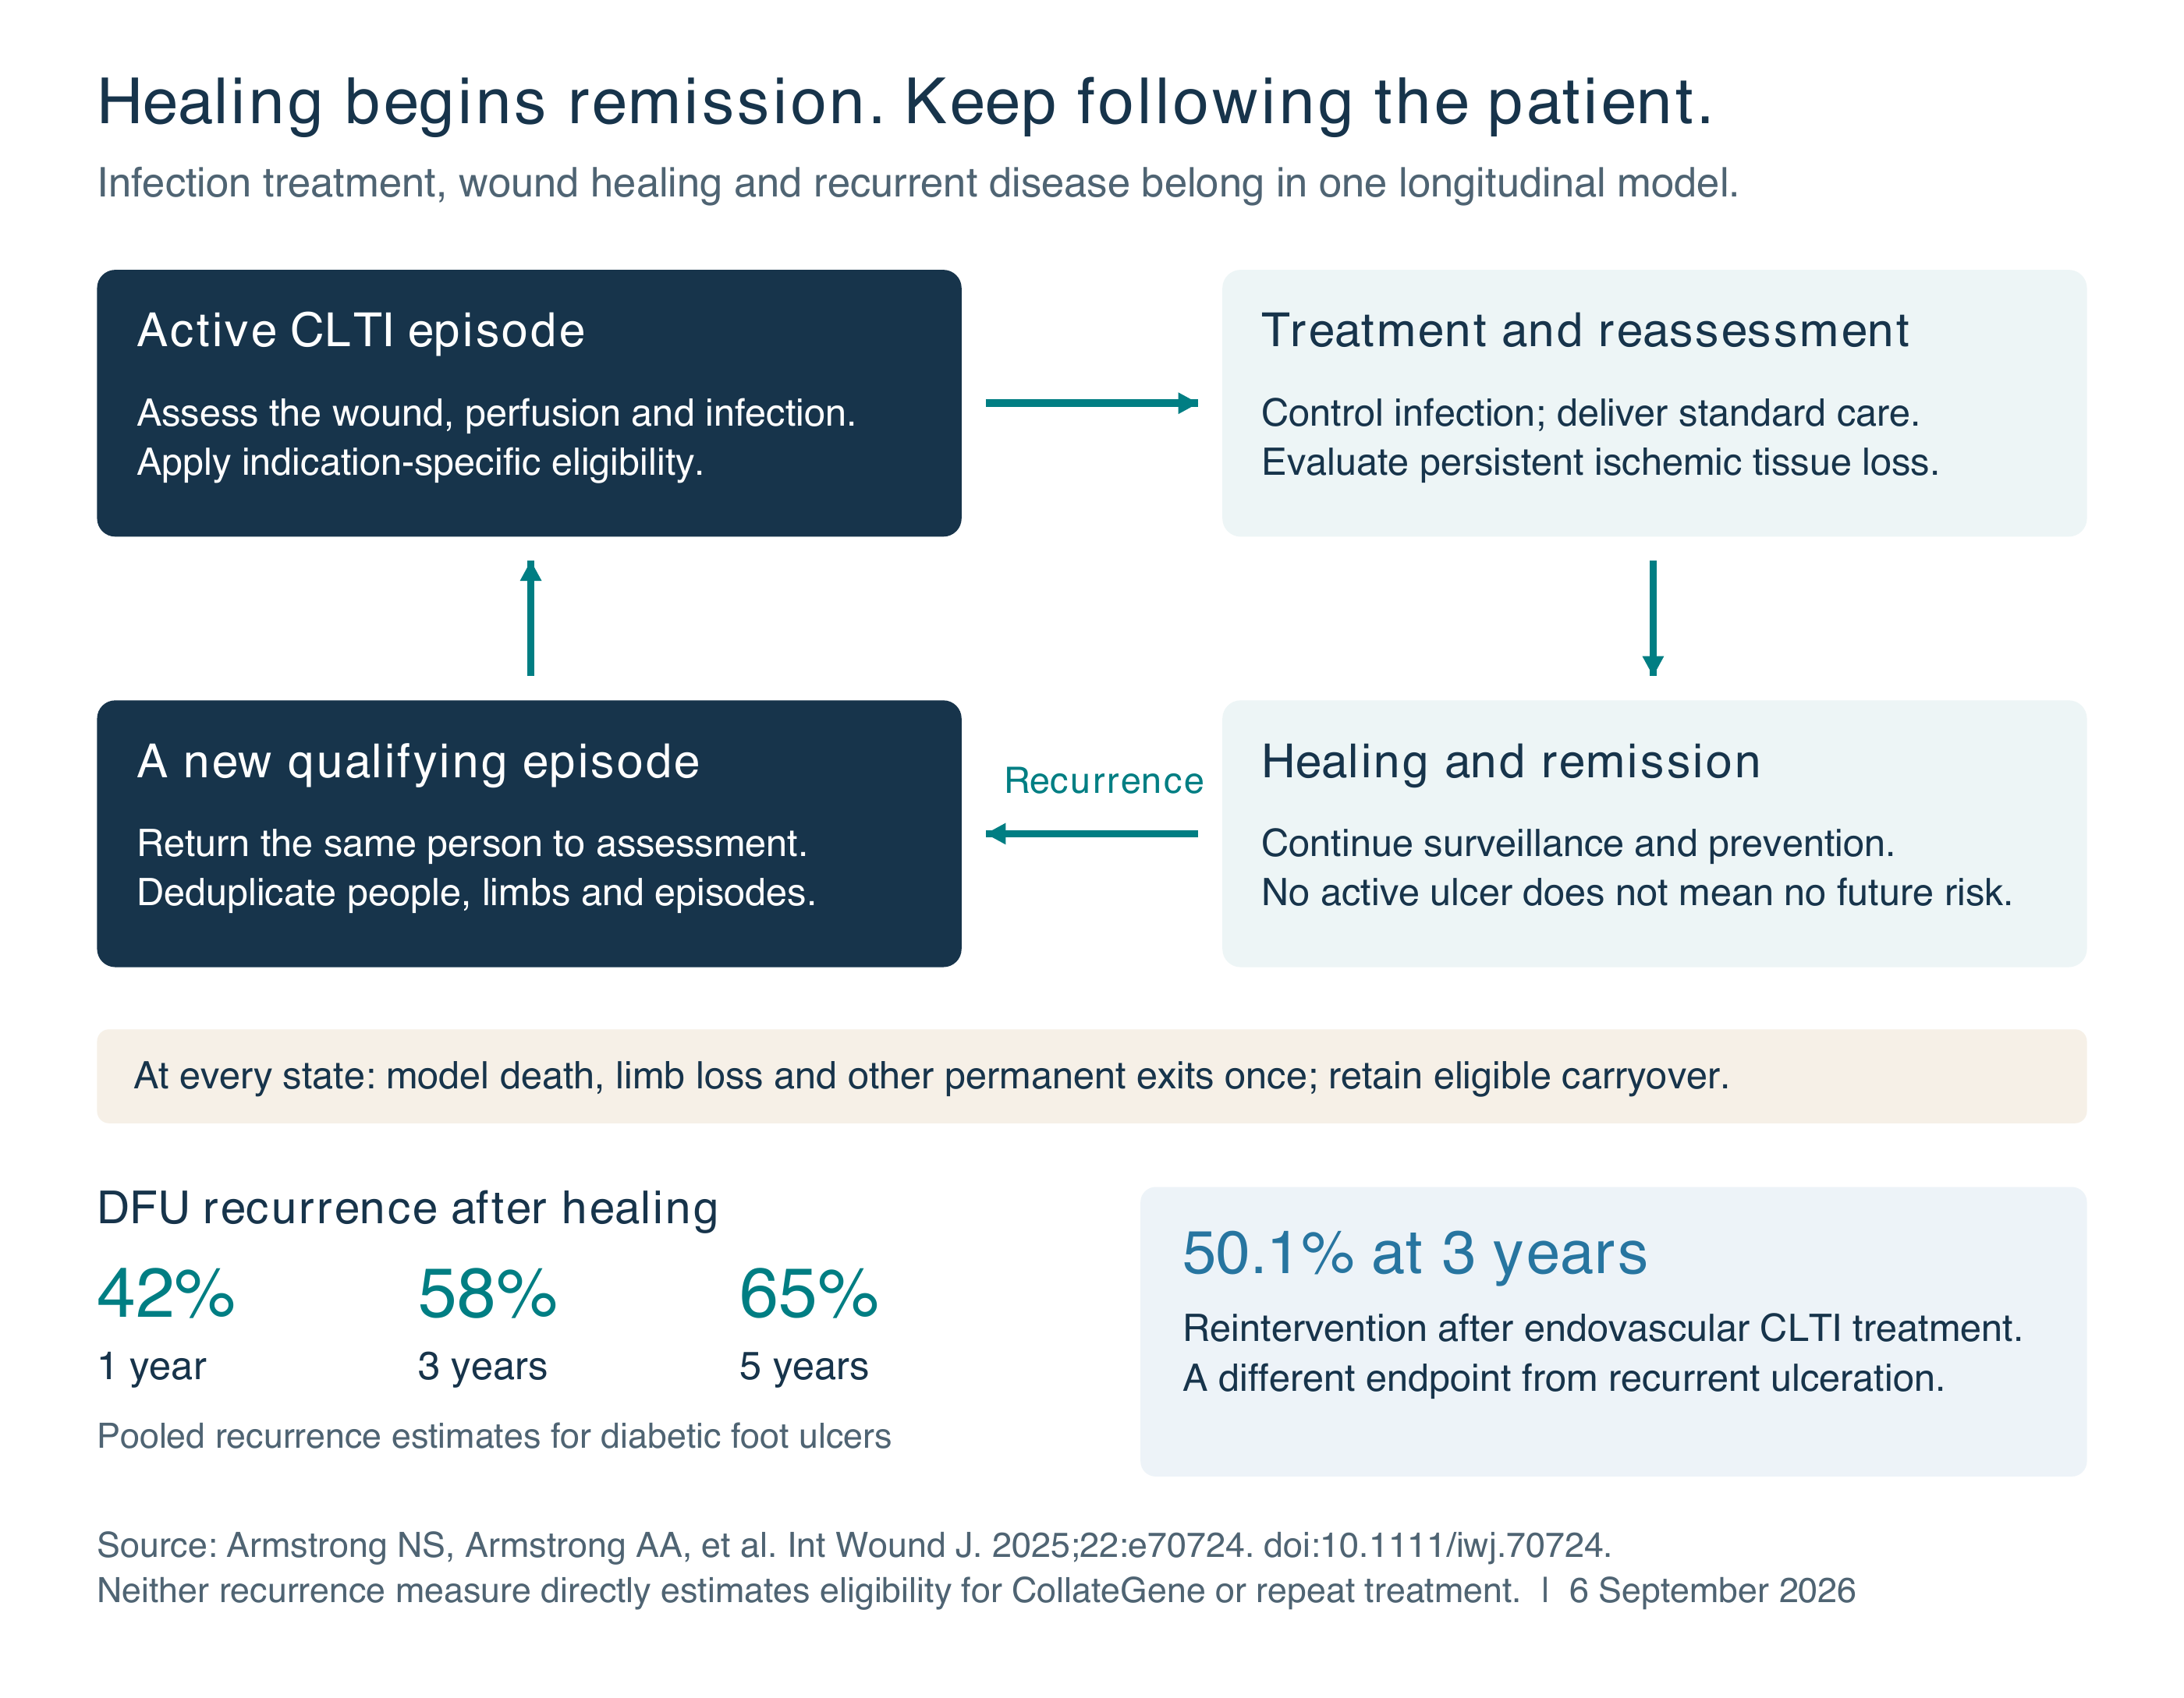
Figure 2. Conceptual state model and distinct recurrence-related endpoints. DFU means diabetic foot ulcer. The displayed rates must not be added together or applied as a gene-therapy re-eligibility rate. Patients with persistent wounds or temporary deferral remain in their relevant states until a transition occurs.
A treatment episode can end; the obligation to prevent the next episode continues. Surveillance and appropriate standard care remain central throughout the pathway.

Show who enters assessment and who actually qualifies
The published 1–2 million US CLTI benchmarks imply a broad continuing need for evaluation. With the same measured activation fraction A and the provisional 10% infection non-return assumption, 900,000–1,800,000 × A remain for further assessment. This does not establish how many meet all CollateGene criteria. [22,23; calculation]
Assessment pathway | Callegari [23] | Midpoint* | Barnes [22]
Disease pool | 1,000,000 | 1,500,000 | 2,000,000
Entering active assessment | 1,000,000 × A | 1,500,000 × A | 2,000,000 × A
After provisional infection step | 900,000 × A | 1,350,000 × A | 1,800,000 × A
Meeting all treatment criteria | Measure | Measure | Measure

*Illustrative midpoint, not a published third estimate. If A = 50% solely as an arithmetic example, 500,000 / 750,000 / 1,000,000 enter assessment and 450,000 / 675,000 / 900,000 remain after the provisional infection step. The 50% is not an estimated activation rate.
The previous estimates of 729,000–815,400 after a severity screen and 82,404–92,171 after commercial assumptions are withdrawn. Their apparent precision depended on an unsupported conversion from population categories to treatment exclusion. They must not be used as clinical population estimates or annual treatment forecasts.
The correct sequence is explicit: identify active patients entering care, treat infection and reassess, determine individual eligibility, then estimate prescribing and access. Leaving the eligibility input unmeasured is more accurate than filling it with a diagnosis-code percentage.

An infection history is different from infection at treatment
The LEGenD-1 registry required an uninfected, nongangrenous ulcer at randomization, with defined wound and perfusion criteria. It did not describe all patients with a previous infection as permanently excluded. Patients recovering from infection can therefore be reassessed, but the registry does not prove that they will satisfy all remaining criteria. [17]
LEGenD-1 was a 75-participant phase II trial in neuroischemic ulcers with toe pressure or transcutaneous oxygen pressure of 30–59 mm Hg. Median healing time was 84 versus 280 days; 12-month healing was 77.6% versus 46.2%. The six-month comparison was 63.3% versus 38.5% (P=0.053). This supports further development in the studied population, not established efficacy across all CLTI stages or demonstrated amputation prevention. [16]
The broad “all CLTI patients with PAD” label in the IQVIA base case is a commercial scenario. Report separately a trial-like ulcer population and plausible future label scenarios. Pure rest-pain patients have no ulcer-healing indication under a trial-like scenario. Conversely, a trial enrollment restriction should not silently become a universal permanent market exclusion. [1,16,17]
Individual CLTI episodes can improve after care; “permanent and progressive” describes persistent underlying disease and continuing risk, not inevitable deterioration in every patient. Treatment eligibility returns only when a new episode satisfies the relevant criteria. Standard infection care, wound care, offloading and indicated revascularization remain necessary. [2,3,17,20]

Separate clinical eligibility from commercial assumptions
The 2038 IQVIA waterfall begins with 290,836 newly diagnosed patients and ends with approximately 15,977 treated patients. These are outputs of the supplied model, not independent measurements of who is suitable for CollateGene. Its 19% severity exclusion remains unvalidated for that purpose. [1]

What the commercial percentages mean
Existing model input | Plain-language meaning
About 28.6% physician prescribing share | The model assumes clinicians would prescribe treatment to about 29 of every 100 patients remaining after its clinical filters.
60% retention of stated prescribing intent | The model keeps 60% of the initial prescribing estimate, reducing it by another 40%.
About 65.8% access to treatment | The model assumes about 66 of every 100 patients remaining at this step obtain treatment.

These percentages describe forecast prescribing and access. They do not measure clinical need or prove who can benefit. Until the clinically eligible population is established, applying them cannot produce a defensible new treated-patient count.

Withdraw the unsupported revised forecasts
The prior comparisons that substituted 9.4% or 14.7% severity exclusions, and the combined forecast derived from those substitutions, are withdrawn. Retaining the existing 19% exclusion in a new calculation does not validate it either. The revised analysis therefore stops before this unmeasured eligibility step.

Build the missing clinical evidence
Define the intended treatment population and assessment window. Use patient-level clinical information to identify active wounds, perfusion, infection resolution, salvageability and all applicable treatment criteria. Estimate the share who qualify after reassessment, including uncertainty, and explain how the data match the target population. [2,3,17]
Then reconnect existing disease, first diagnoses, untreated carryover and recurrent episodes to each year’s eligible population. Count people, limbs and episodes separately. Prescribing and access should be recalculated for that clinical population, rather than carried over from an unsupported mix of diagnosis-code categories.
A 1–2 million-person disease pool and approximately 291,000 annual first diagnoses can coexist. One is a stock; the other is an inflow. Neither can be compared directly with the 4,700-patient downside treatment forecast to establish the size of a forecasting error.

Requested revisions before the model is used externally
The incident-only view shows one part of a much larger epidemiological iceberg. The model must follow the person through persistent disease, infection treatment, remission and recurrence. The starting range is 1–2 million people with CLTI, citing each endpoint separately and showing a 1.5 million midpoint as an arithmetic scenario. Clinical activation and timing must be modeled explicitly. [22,23]
Please return a revised workbook and corresponding report exhibits that address the following points:
- Remove unsupported diagnosis-code exclusions. Reconcile the Schraepen symptom groups. Do not use CLIPPER’s 9.4%, a derived average, or an unvalidated severity percentage as treatment ineligibility. Supply patient-level wound, perfusion and treatment-eligibility evidence after reassessment.
- Replace one-time infection deletion with a transition model. Specify resolution, time to reassessment, residual clinical eligibility, healing, death and amputation. Show a 10% whole-cohort non-return scenario and wider bounds; do not relabel it an observed “chronic untreatable infection” rate.
- Rebuild column one around the chronic disease pool. Carry Callegari’s 1.0 million and Barnes’s 2.0 million benchmarks through every downstream calculation, with a labeled 1.5 million midpoint. Reconcile prevalence, annual first diagnoses and clinical activation. Supply code lists, age-specific denominators and source-year weights; reconcile Kwong’s prevalence windows and the Baser denominator error.
- Show rolling carryover and recurrence in remission. Use the Armstrong and Armstrong IWJ 2025 framework to retain healed patients in a linked remission pool. Account for every later cohort and distinguish a new patient, a recurrent ulcer, a second limb and a repeat treatment course.
- Keep trial evidence, assumed label, clinical eligibility, prescribing and access visible. Deliver broad-label and trial-like scenarios. Recheck downstream uptake and access when the population mix changes; disclose the segment-level mechanics.
- Provide a bridge from the current model. Show the contribution of each revision separately and then jointly, for each year and for unique eligible and treated patients. Supply the workbook assumptions and formulas, rather than only replacement slides.

Materials reconciled for this update
This review reconciles the September 6 and September 2 “Armstrong NEW Report” email chain, Chieka Sasakura’s September 1 analysis, the three attached IQVIA materials, the July 19 clarification, the August 17 brief and correspondence, and the Apple Note titled “IQVIA Meeting.” Primary papers and the trial registry were checked where accessible. The live forecast workbook, underlying survey records and full extraction tables were not supplied. Those gaps are identified as audit requests, not filled with assumed precision.
Two additional exhibit discrepancies need reconciliation: the July infection justification cites Mustapha 2019, while the August exhibit cites Ramachandran 2023; and the base waterfall uses a $35,000 list price while an access exhibit discusses $40,000 WAC. The commercial ratios are described for interpretation only; this revision makes no new treated-patient or revenue estimate. [1]

Companion website
Background materials are available at the CollateGene population website. The companion pages updated September 8 align with this revision and provide clinical pathway, mortality, infection and recurrence graphics, linked manuscripts and downloadable materials. They distinguish the disease pool from annual treatment flow and identify the assumptions behind every displayed scenario. [19]

References and source notes
1. IQVIA and AnGes source materials reviewed. Annotated IQVIA slide deck dated August 28, 2026, slides 2–4 and 7–9, reproducing final-report pages 28 and 38 and selected access exhibits; CollateGene IQVIA Patient Population Justification_IQVIAResponse_19July2026.docx; and IQVIA-AnGes_CollateGene Market Research_Potential PopulationUpdates_19July2026.pptx. Supplied in Charles M. Zelen’s September 6, 2026 “Armstrong NEW Report” email. The forwarded September 1 table supplies the four incidence inputs used in the rate-ratio sensitivity. Internal materials; not peer-reviewed epidemiologic evidence.
2. Conte MS, Bradbury AW, Kolh P, et al. Global vascular guidelines on the management of chronic limb-threatening ischemia. Eur J Vasc Endovasc Surg. 2019;58(1S):S1–S109.e33. Recommendations 6.6–6.8 support integrated staging and reassessment after infection procedures. Source
3. Senneville E, Albalawi Z, van Asten SA, et al. IWGDF/IDSA guidelines on the diagnosis and treatment of diabetes-related foot infections. Diabetes Metab Res Rev. 2024;40(3):e3687. Guideline labeled IWGDF/IDSA 2023. Source
4. Boulton AJM, Armstrong DG, Kirsner RS, et al. Diagnosis and Management of Diabetic Foot Complications. Arlington, VA: American Diabetes Association; 2018. Management of Infection, Outcome section. doi:10.2337/db20182-1. Source
5. Pham TT, Gariani K, Richard JC, et al. Moderate to Severe Soft Tissue Diabetic Foot Infections: A Randomized, Controlled, Pilot Trial of Post-debridement Antibiotic Treatment for 10 versus 20 days. Ann Surg. 2022;276(2):233–238. doi:10.1097/SLA.0000000000005205. Source
6. Altmann D, Waibel FWA, Forgo G, et al. Timing of Revascularization and Parenteral Antibiotic Treatment Associated with Therapeutic Failures in Ischemic Diabetic Foot Infections. Antibiotics. 2023;12(4):685. doi:10.3390/antibiotics12040685. Source
7. Lipsky BA, Armstrong DG, Citron DM, et al. Ertapenem versus piperacillin/tazobactam for diabetic foot infections (SIDESTEP): prospective, randomised, controlled, double-blinded, multicentre trial. Lancet. 2005;366:1695–1703. doi:10.1016/S0140-6736(05)67694-5. Source
8. Pachon Burgos A, et al. Risk factors associated with amputations in patients with diabetic foot infection. Seven years of experience in a reference hospital in Panama. The diabetic foot study group at Chiriqui (the FOOTCHI study group). Endocrine and Metabolic Science. 2024;16:100184. Source
9. Schraepen C, van der Laan L, Smet N, Meulenbroek A, Fourneau I. Chronic Limb-Threatening Ischemia does not Enclose a Homogenous Population: Time for a More Detailed Classification. Int J Angiol. 2024;33(1):8–14. Published online December 15, 2023. Table 1. doi:10.1055/s-0043-1777414. Source
10. Fanaroff AC, Dayoub EJ, Yang L, et al. Development and Description of a National Cohort of Patients With Chronic Limb-Threatening Ischemia. J Soc Cardiovasc Angiogr Interv. 2023;2(4):100982. CLIPPER cohort; claims-based staging. Source
11. Kwong M, Rajasekar G, Utter GH, Nuño M, Mell MW. Updated estimates for the burden of chronic limb-threatening ischemia in the Medicare population. J Vasc Surg. 2023;77(6):1760–1775. doi:10.1016/j.jvs.2023.01.200. Source
12. Nehler MR, Duval S, Diao L, et al. Epidemiology of peripheral arterial disease and critical limb ischemia in an insured national population. J Vasc Surg. 2014;60(3):686–695.e2. doi:10.1016/j.jvs.2014.03.290. Source

References and source notes continued
13. Mustapha JA, Katzen BT, Neville RF, et al. Disease Burden and Clinical Outcomes Following Initial Diagnosis of Critical Limb Ischemia in the Medicare Population. JACC Cardiovasc Interv. 2018;11(10):1011–1012. The 0.22% extraction shown in this review is explicitly attributed to the circulated IQVIA table and requires workbook reconciliation. Source
14. Baser O, Verpillat P, Gabriel S, Wang L. Prevalence, Incidence, and Outcomes of Critical Limb Ischemia in the US Medicare Population. Vasc Dis Manag. 2013;10(2):E26–E36. Methods and Results distinguish the source population from 68,074 new CLI cases. Source
15. Deng L, Du C, Liu L, et al. Forecasting the Global Burden of Peripheral Artery Disease from 2021 to 2050: A Population-Based Study. Research. 2025;8:0702. Table 1: high-income North America PAD prevalence 16.41 million in 2021 (95% UI 14.68–18.34 million), projected to 31.08 million in 2050. Regional PAD context, not a US CLTI estimate or multiplier. Source
16. Armstrong DG, Conte MS, Mills JL, et al. Anatomically Directed Lower Extremity Gene Therapy for Ulcer Healing: A Double-Blind, Randomized, Placebo-Controlled Study (LEGenD-1). Circ Cardiovasc Interv. 2026;19:e015648. Published online November 4, 2025. Source
17. ClinicalTrials.gov. NCT04267640. Study of AMG0001 to Improve Ulcer Healing and Perfusion in Subjects With Peripheral Ischemic Ulcers. Eligibility criteria read September 6, 2026, including absence of infection or gangrene at randomization, wound size and perfusion restrictions. Source
18. Armstrong DG, Boulton AJM, Bus SA. Diabetic Foot Ulcers and Their Recurrence. N Engl J Med. 2017;376:2367–2375. Background for recurrent wound episodes and the distinction between healing and ongoing disease risk; not used to calculate CollateGene-treated patients. Source
19. CollateGene companion website. Population and scenario pages updated September 8, 2026. Diagnosis-code exclusions are withdrawn; figures and manuscript links distinguish clinical evidence, assessment and commercial assumptions. The website is an explanatory companion, not independent clinical evidence. Source
20. Armstrong NS, Armstrong AA, Mills JL, Conte MS, Tan TW, Swanson RS, Armstrong DG. Three-Year Recurrence in People With Diabetic Foot Ulcers and Chronic Limb Threatening Ischemia Is Comparable to Cancer. Int Wound J. 2025;22(8):e70724. Published July 22, 2025. The report distinguishes DFU recurrence from CLTI endovascular reintervention. Source
21. Allison MA, Armstrong DG, Goodney PP, et al. Health Disparities in Peripheral Artery Disease: A Scientific Statement From the American Heart Association. Circulation. 2023;148(3):286–296. doi:10.1161/CIR.0000000000001153. Source
22. Barnes JA, Eid MA, Creager MA, Goodney PP. Epidemiology and Risk of Amputation in Patients With Diabetes Mellitus and Peripheral Artery Disease. Arterioscler Thromb Vasc Biol. 2020;40(8):1808–1817. doi:10.1161/ATVBAHA.120.314595. CLTI section: 1.28% of US adults over 40, approximately 2 million; cites Duff et al, Vasc Health Risk Manag. 2019;15:187–208. Review-level prevalence synthesis. Source
23. Callegari S, Romain G, Cleman J, et al. Long-Term Mortality Predictors Using a Machine-Learning Approach in Patients With Chronic Limb-Threatening Ischemia After Peripheral Vascular Intervention. J Am Heart Assoc. 2024;13:e034477. Introduction: approximately 1 million US patients with CLTI and up to 11% of PAD patients. Background epidemiology, not a new national prevalence estimate from the PVI cohort. Source
24. Conte MS, Azene E, Doros G, et al. Secondary interventions following open vs endovascular revascularization for chronic limb threatening ischemia in the BEST-CLI trial. J Vasc Surg. 2024;79(6):1428–1437.e4. Primary reintervention analysis cited by the IWJ paper. Source

